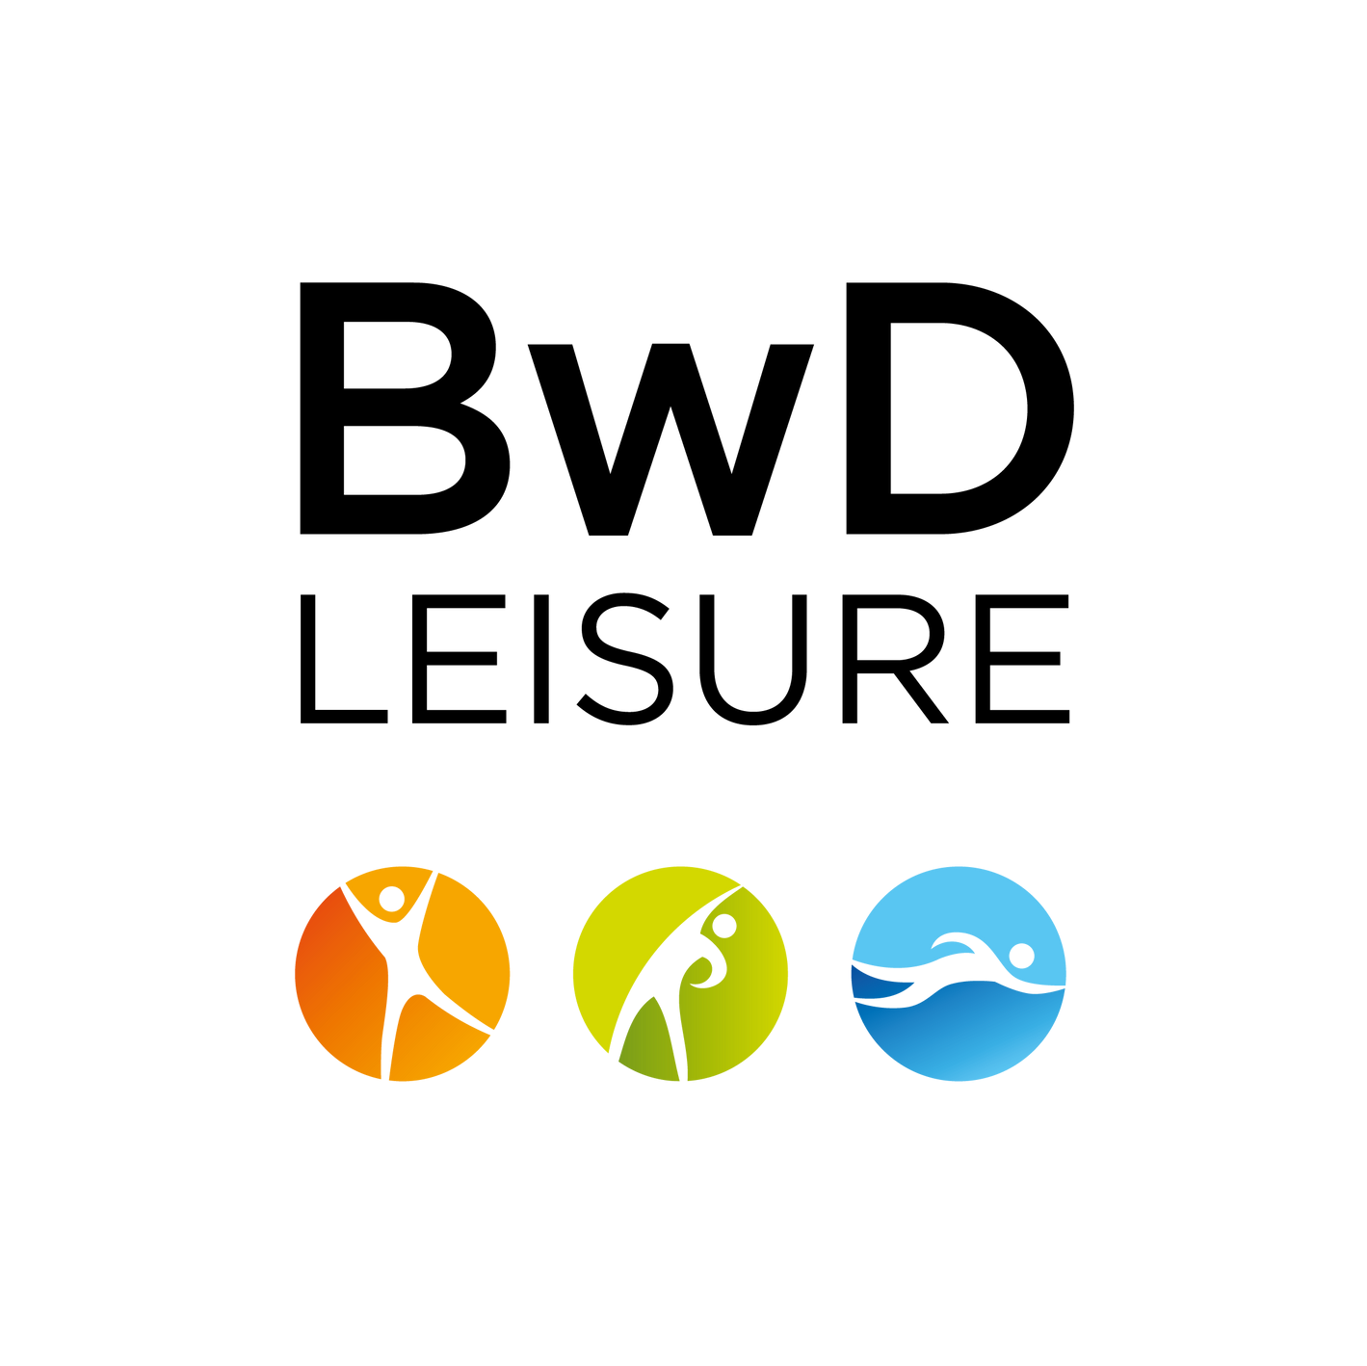
Under 10s Mixed 7-A-SIDE
7-A-SIDE
Under 9s Mixed
Morning
Under 7s Mixed 5-A-SIDE Under 8s Mixed 5-A-SIDE Afternoon

BLACKBURN WITH DARWEN BOROUGH COUNCIL' S
END OF SEASON
FOOTBALL FESTIVAL
SPONSORED BY BWD LEISURE
SATURDAY 13 TH AUGUST & SUNDAY 14 TH AUGUST 2022

WITTON 3G PITCHES £50 ENTRY PER TEAM
Saturday 13th August
Sunday 14th August

All teams must be affiliated to their respective County Football Association All age categories apply as at midnight 31/08/2022 (as per 2021/22 season)
All day Under 11s Mixed
9-A-SIDE

Under 12s Mixed 9-A-SIDE
Closing Date for Applications - 29th July 2022
Each category limited to 6 teams
To book your place, complete and return the Application Form and return it, together with your fee to Witton Park Arena,Preston Old Road, BB2 2TP
Cheques to be made payable to "Blackburn with Darwen Borough Council" For further information call 01254 585555

BLACKBURN WITH DARWEN BOROUGH COUNCIL' S
END OF SEASON
FOOTBALL FESTIVAL
SPONSORED BY BWD LEISURE

TEAM APPLICATION FORM
Club Name: Contact Name:

Address:

Post Code:

Home Tel: Mobile:

Email Address:

County Football Association Affiliation Number:

Saturday 13th August
Sunday 14th August

Under 7s Mixed Under 8s Mixed Under 9s Mixed Under 10s Mixed
Under 11s Mixed Under 12s Mixed

All teams must be affiliated to their respective County Football Association All age categories apply as at midnight 31/08/2022 (as per 2021/22 season)
Closing Date for Applications - 29th July 2022
Each category limited to 6 teams
To book your place, complete and return the Application Form and return it, together with your fee to Witton Park Arena,Preston Old Road, BB2 2TP
Cheques to be made payable to "Blackburn with Darwen Borough Council" For further information call 01254 585555

